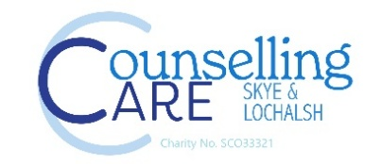
Job Description
CYP Lead Counsellor (Part-Time)

24.5 hours per week | £27.260 per annum | Fixed-term (1 year, continuation dependent on funding)
Location: Schools – Skye and Lochalsh
Counselling Care Skye and Lochalsh provide vital early intervention mental health support across our rural and island communities. We are currently seeking a Lead Counsellor for our children’s service running a school-based counselling service for children and young people from aged five to eighteen.
This is an exciting opportunity to play a key role in a small, community-based organisation, helping to provide an essential service for our younger members of society.
Who We’re Looking For
We are seeking an experienced and compassionate counsellor who is able to lead and support the delivery of high-quality counselling services for children and young people in Skye and Lochalsh.

The successful candidate will manage a caseload, oversee staff workloads, coordinate referrals, maintain reporting systems, liaise and report to the board of trustees and work collaboratively with schools and external agencies to ensure effective support for young people and families.

What We Offer
- A supportive and collaborative team environment
- Opportunities for training and professional development
- The chance to make a real difference to mental health support in the Skye and Lochalsh community
Additional Information
The role requires a driving license and a car.
Closing date: 08/08/26
For an informal discussion or to request an application pack, please contact: dolina.munro@counsellingcaresl.org
Equality Statement
Counselling Care Skye and Lochalsh is committed to equality, diversity and inclusion and welcomes applications from all sections of the community.

